Home | About Us  ├── About CoSafe  ├── Meet Our Team  ├── Our Values  ├── Our Campus  Our Clients  └── Why Choose Us
Training
Consultancy
Courses
ESG & CSR | Environmental Services  Social Services  Governance Services  Green Building & Sustainability
Know More | Gallery  Blogs  Job Placement  Faq’s(Students, Corporate)
Contact Us

Course Page | Examin - Education and LMS Template
Blog page | Bizan - Business & Finance HTML5 Template
Corporate Service Page | Gerow - Business Consulting HTML Template Preview - ThemeForest
Ideal Template Design | Gerow - Business Consulting HTML Template Preview - ThemeForest
Home Page | Home One || Insur || Insur HTML 5 Template
Home Page | Home Two || Insuba || HTML Template Is The Perfect Solution For Any Type Of Insurance Company
Services with no seperate page | Insurance 02 || Insur || Insur HTML 5 Template | ESG
Consultancy Page | Life insurance || Insur || Insur HTML 5 Template
Menu Bar | Business Insurance || Insuba || HTML Template Is The Perfect Solution For Any Type Of Insurance Company
Menu Drop Down | https://bexon-react.vercel.app/
All Services | https://html.webextheme.com/novaly/page-all-services.html
Best HOme page design | Home One || Insuba || HTML Template Is The Perfect Solution For Any Type Of Insurance Company
Footer | Examin - Education and LMS Template
More Clarity | Home One || Insuba || HTML Template Is The Perfect Solution For Any Type Of Insurance Company
Contact Us | Bizan - Business & Finance HTML5 Template

Home Banner | Hitesh, Niyaz, Mahadev | 1 Corporate achivement, 1 diploma achievement
Affiliations | Hitesh, Pratika, Mahadev | ISO, NSC, NCVTE, NSDVE, MSME
Happy Clients | Hitesh, Snhea, Mahadev | Top 15 Clients
Reviews  (“What Our Clients Say About Us”) | Hitesh, Sneha, Mahadev, Pratika | Top 5 Corporate, 5 Students  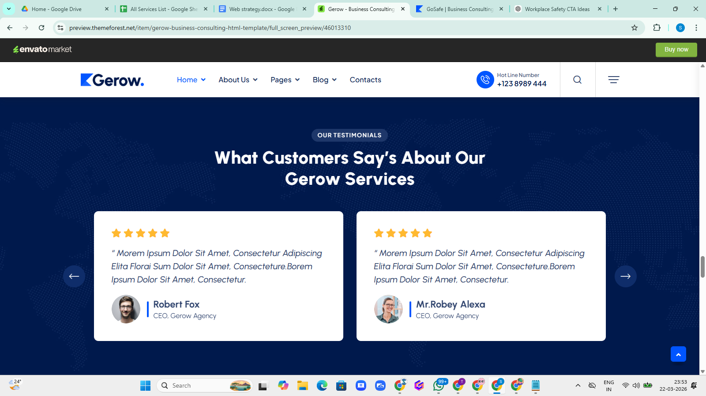
Headline:  “Meet Our Expert Team”  Not required social media link, See more and divert to Our Team page below the about us dropdown | Hitesh, Sneha, Mahadev | 4 Diploma Trainer, 10 Corproate Trainer  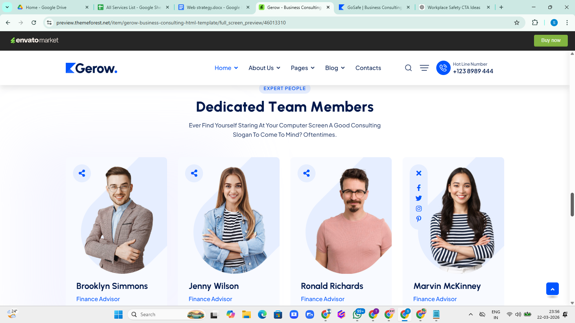
Frequently asked questions(FAQ’s) | Hitesh, Mahadev | 3 Corporate, 3 Diploma then read more
Our Work Process Corporate Service Roadmap | Hitesh, Mahadev | 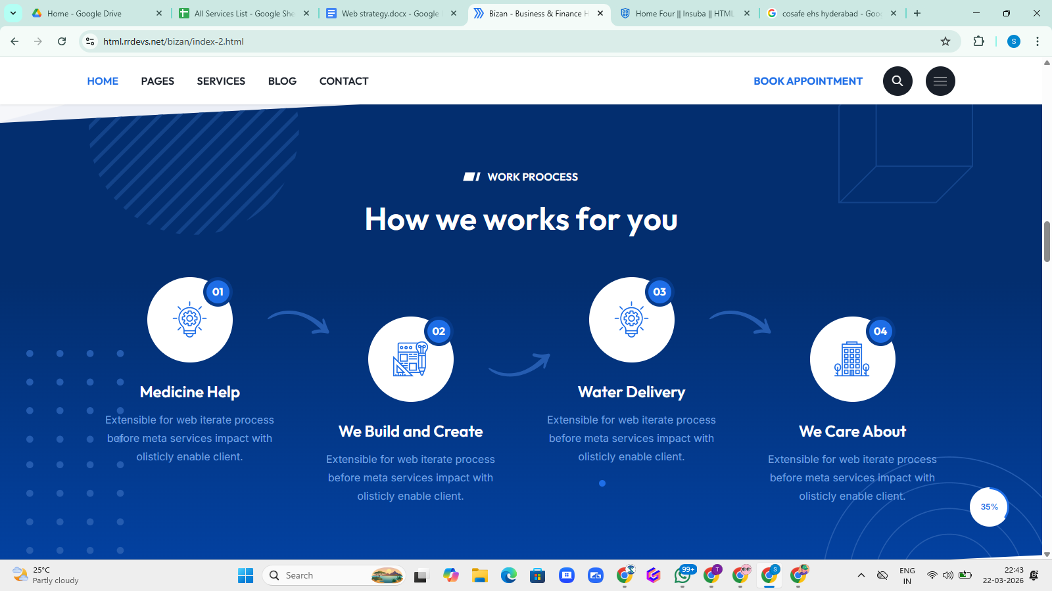
Our Milestone | Hitesh, Mahadev | 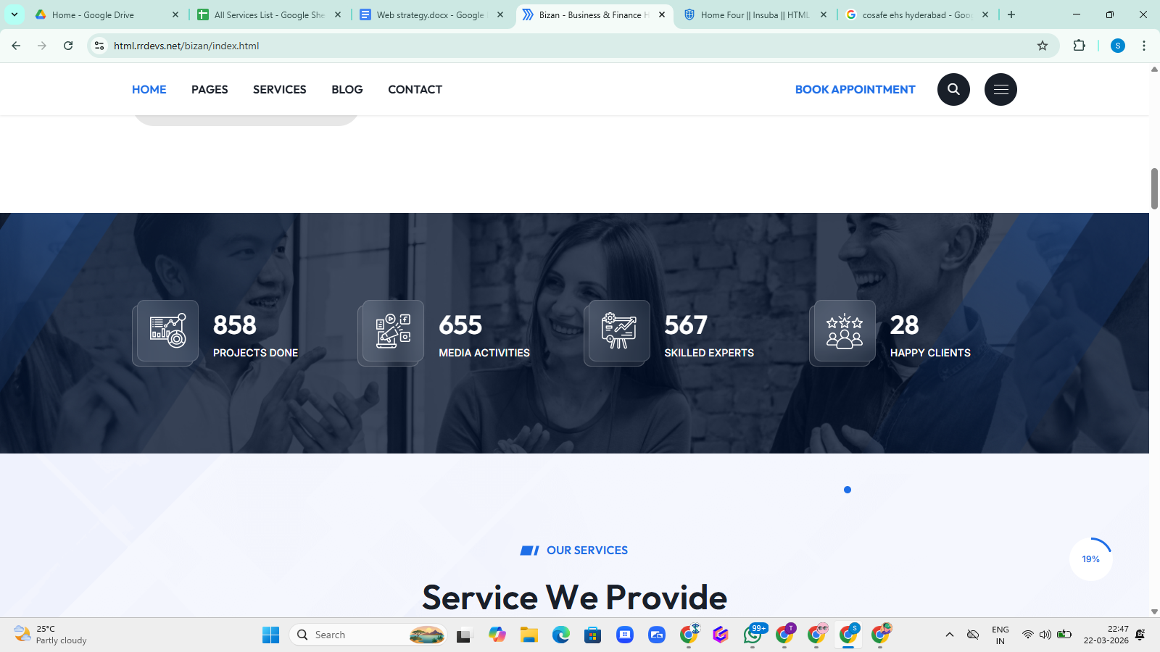

Home | remove address from top bar  Mail Id-  corporate@cosafe.in  put all actual social media link  CoSafe In Logo with trademark  Add Home Banner down to Menu Bar  Add Verify Certificates on top bar  add bangalore, hyderabad both address on three line and footer  Bangalore Address- Warehouse No. 4, Janatha Colony, Dommasandra, Bangalore, Karnataka - 562125  Hyderabad Address: First Floor, Santhosh Reddy Complex, 23-171/1, Madhura Nagar, Shamshabad, Hyderabad, Telangana 501218
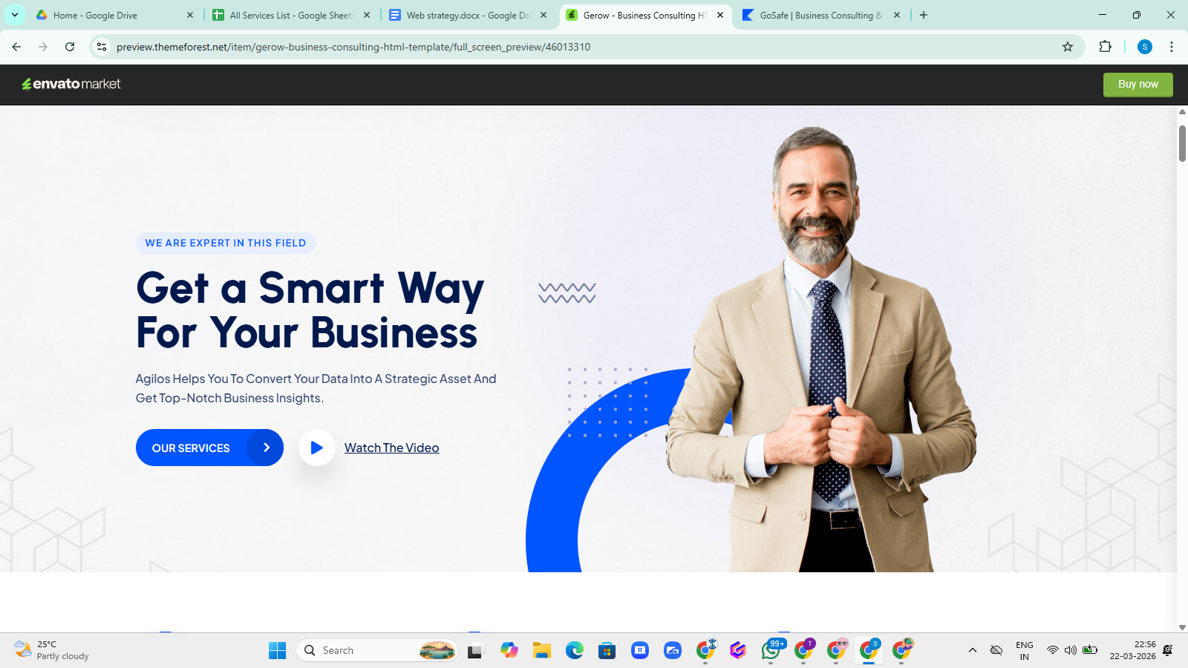 | Tagline:  Trusted EHS Excellence Partner  Heading:  Transforming Safety into Workplace Excellence  Description:  CoSafe delivers practical safety training, compliance, and risk management solutions for safer workplaces.
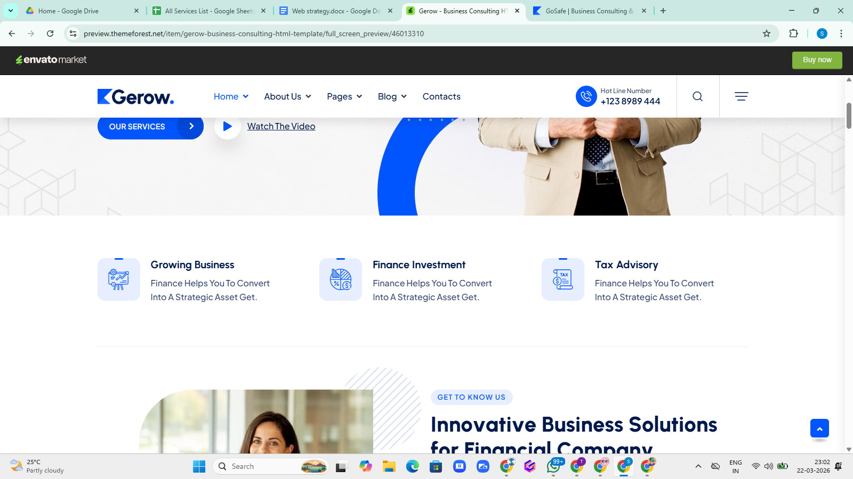 | 🔷 Box 1  Safety Training  Practical, industry-focused EHS training programs for workforce and professionals.  🔷 Box 2  EHS Consultancy  Expert guidance on compliance, risk assessment, and workplace safety management.  🔷 Box 3  Audits & ESG Solutions  Comprehensive audits and ESG services to ensure compliance and sustainability.
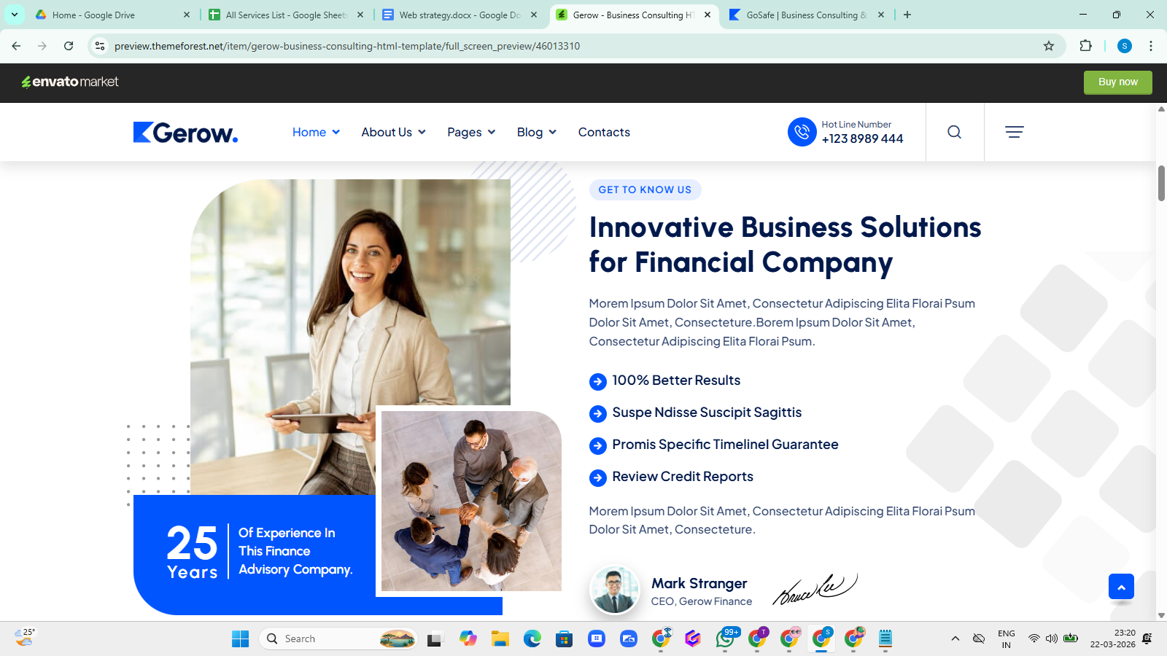 | ✅ Small Tagline  GET TO KNOW COSAFE EHS  ✅ Main Heading  Practical EHS Solutions for Safer & Compliant Workplaces  ✅ Short Description  CoSafe EHS Excellence Center delivers industry-focused safety training, consultancy, and compliance solutions. We help organizations build a strong safety culture through practical learning, expert guidance, and structured safety systems.  ✅ Bullet Points  ✔ Improved Workplace Safety & Reduced Incidents  ✔ Strong Compliance with Regulatory Standards  ✔ Skilled & Industry-Ready Workforce  ✔ Faster Emergency Response & Risk Control  ✅ Closing Line (Optional)  Delivering measurable safety outcomes through practical training and expert-driven solutions.  ✅ Blue Box (Left Side)  5+ Years of Excellence in Safety Training & Consultancy | Technical Director( Yet to decide, Signature to be decide)  Two good Pictures of Training  put read more and divert to why to choose us under about us dropdown
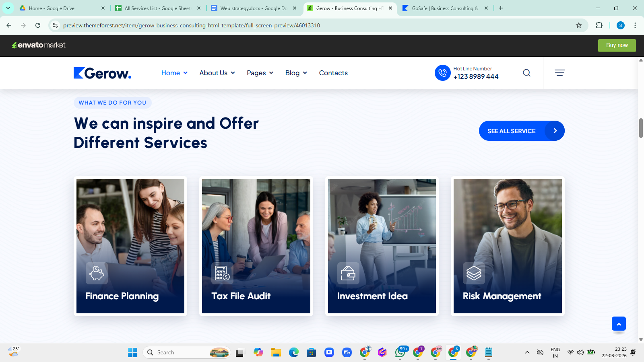 | ✅ Section Tagline (Small Text)  What We Do For You  ✅ Main Heading  Our Core EHS Services  ✅ Service Cards (Final Content)  🔹 Practical Learning Campus  🔹 On-Site Training  🔹 Audit & Consultancy  🔹 Industry Safety Courses  ✅ Button Text  Explore All Services | Not required description on service cards  Image should as actual or similar to indicate services
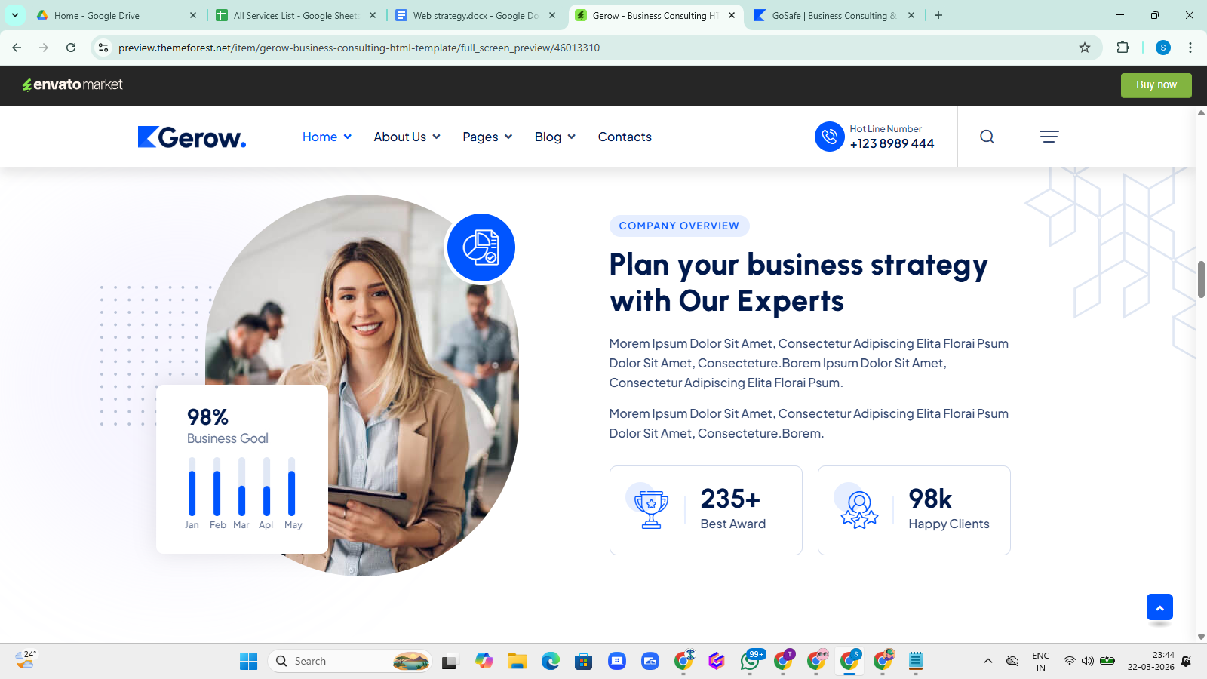 | ✅ RIGHT SIDE CONTENT (FINAL VERSION)  Main Heading  Plan Your Safety Training With Us  Sub Heading  On-Site at Your Workplace or At Our Practical Learning Campus  Description  CoSafe EHS offers flexible, industry-focused safety training designed for real-world challenges. Whether at your site or our practical campus, our programs focus on hands-on learning, live simulations, and job-ready skills to ensure maximum effectiveness.  ✅ ICON BAR (VERY IMPORTANT – Your Idea)  Use this as highlight stats (with icons) 👇  🔹 20+ Training Modules  🔹 20+ Expert Trainers  🔹 100% Practical Learning  🔹 Real-Time Simulations  👉 This will sit just below description (like trust indicators)  ✅ BUTTONS (CTA – VERY IMPORTANT)  Use 2 buttons side by side:  🔵 Watch Campus Tour (Primary – Video popup)  ⚪ Visit Our Campus (Secondary – Contact / Location page)  🎥 LEFT SIDE (VIDEO STRUCTURE IDEA)  🔹 Main Video (Auto-play or Click)  👉 Campus walkthrough + live training visuals  🔹 Overlay Tag on Video  🎬 Real-Time Practical Training
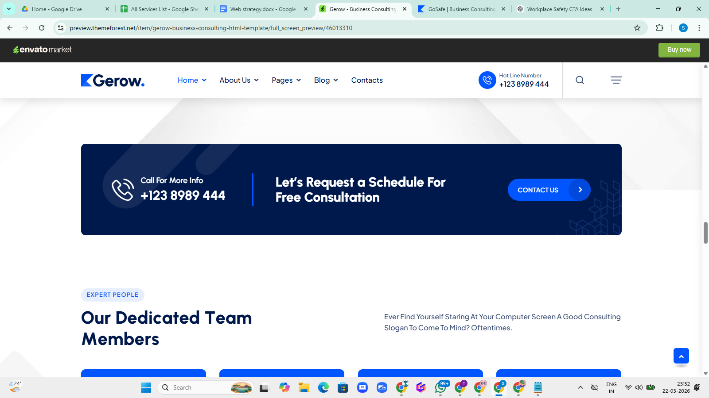 | “Let’s Connect & Strengthen Your Workplace Safety” | Mobile no +91- 7892978960  Contact us divert to contact us page
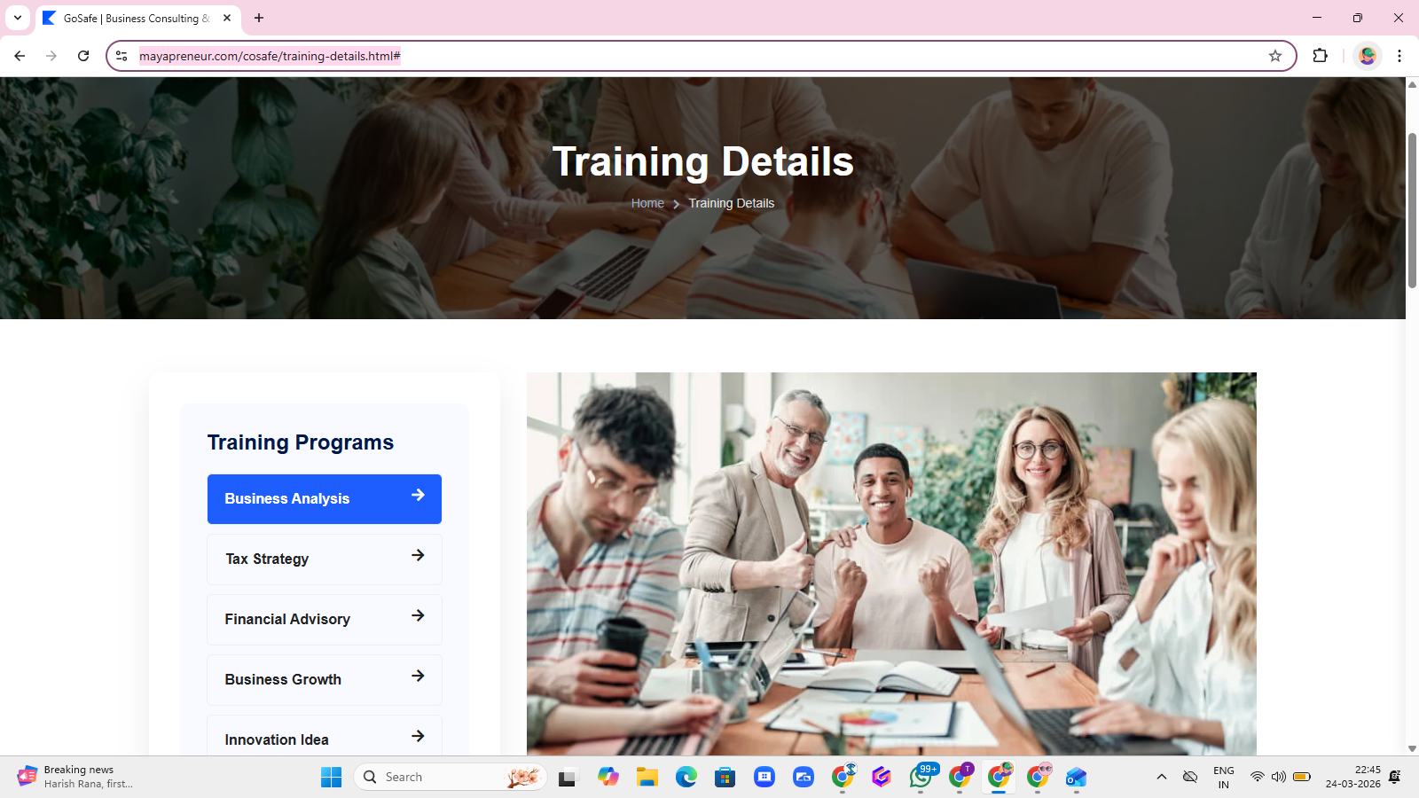 | 🟢 2. LEFT SIDE MENU (Training Programs)  ❌ Current:  - Business Analysis  - Tax Strategy  - Financial Advisory  - Business Growth  - Innovation Idea  ✅ Replace With (Your Actual Courses):  - First Aid Training  - Fire Safety Training  - POSH Awareness  - Electrical Safety Training  - Disaster Management  - Road safety Training  👉 This becomes your course navigation menu
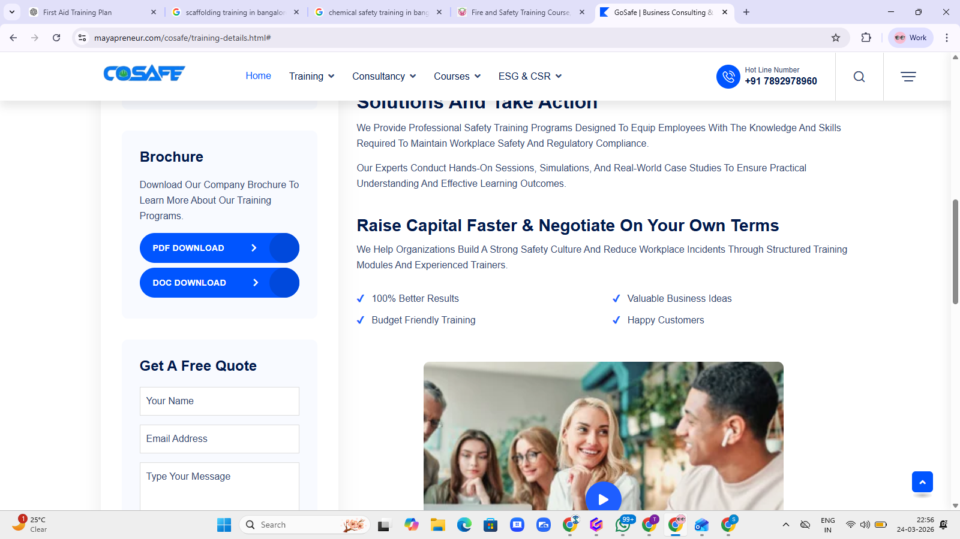 | Remove download option, need to put Portfolio Download option in the Footer
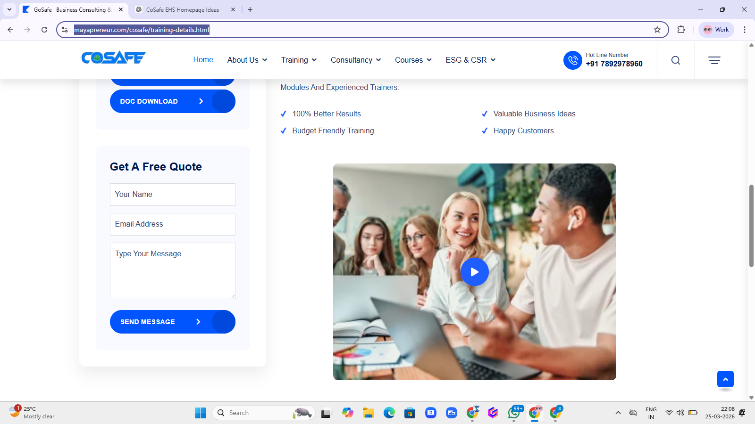 | Request Training Proposal- Headline  After submission put this line as below-  Our experts will connect with you to understand your safety training and compliance needs.
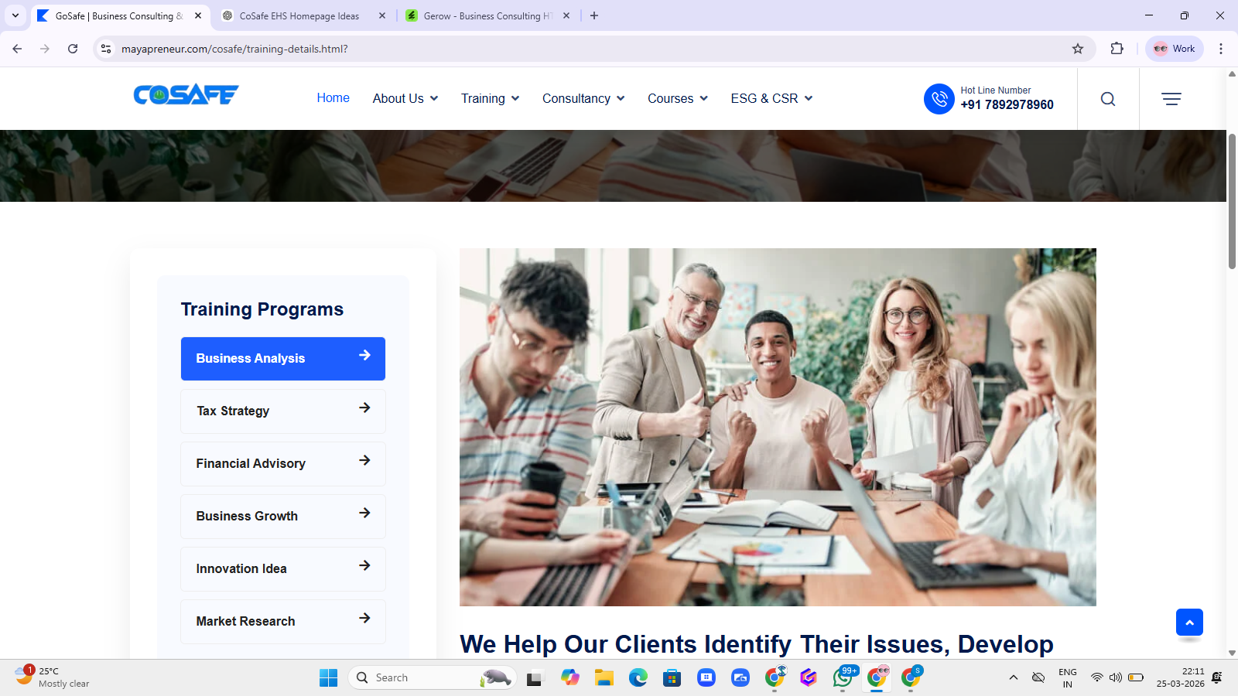 | Not required image as huge data will be over the website
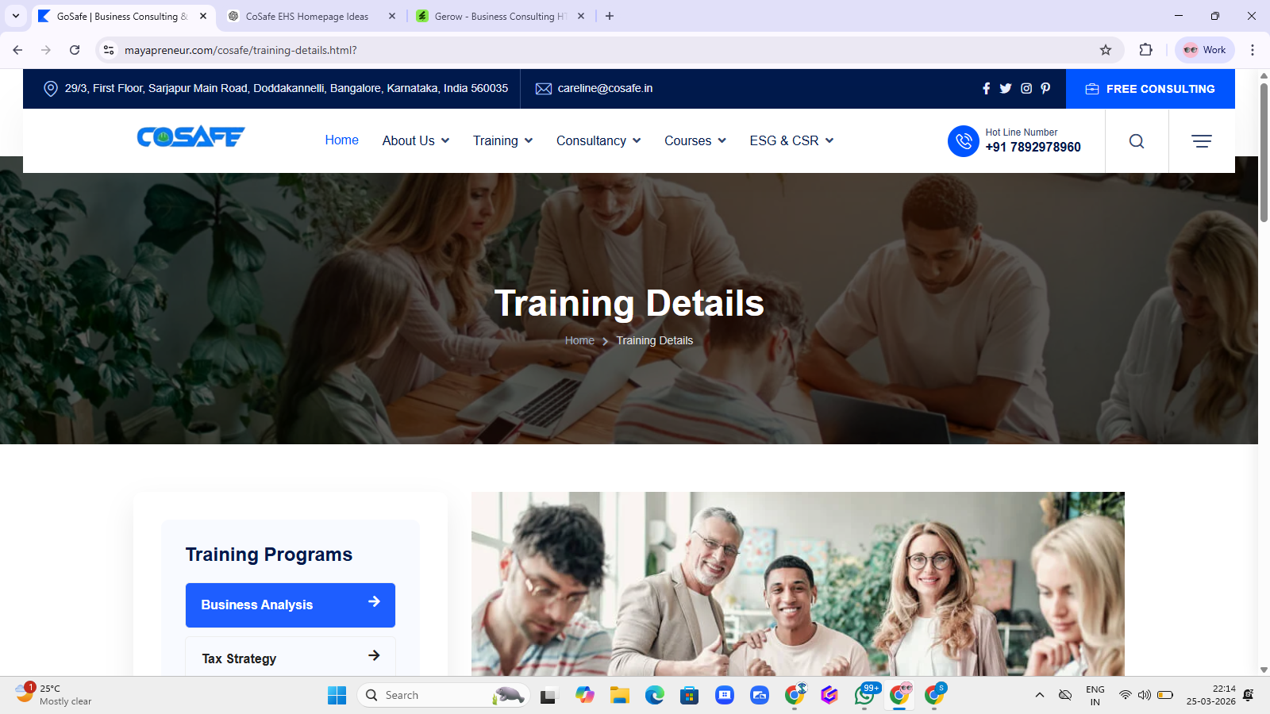 | Training details behind we will design one common banner to upload same on all of the training pages | Niyaz
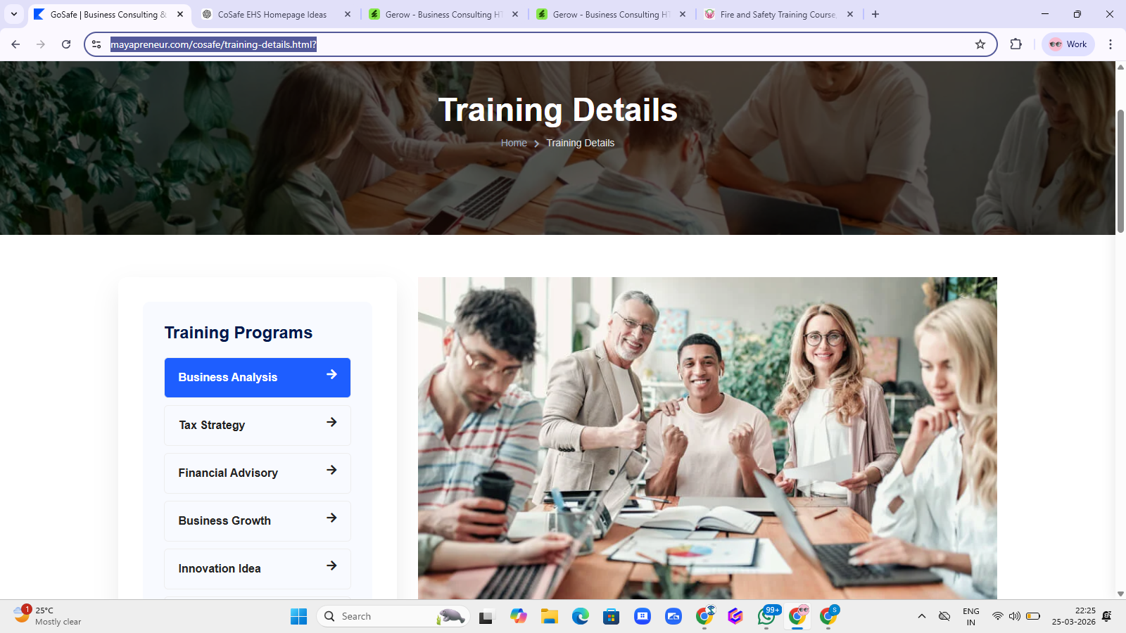 | Below to the training details and in front of training program, i want the 4 tabs in one line to view the details  - Overview  - Training Modules  - Training Methodology  - Program Details
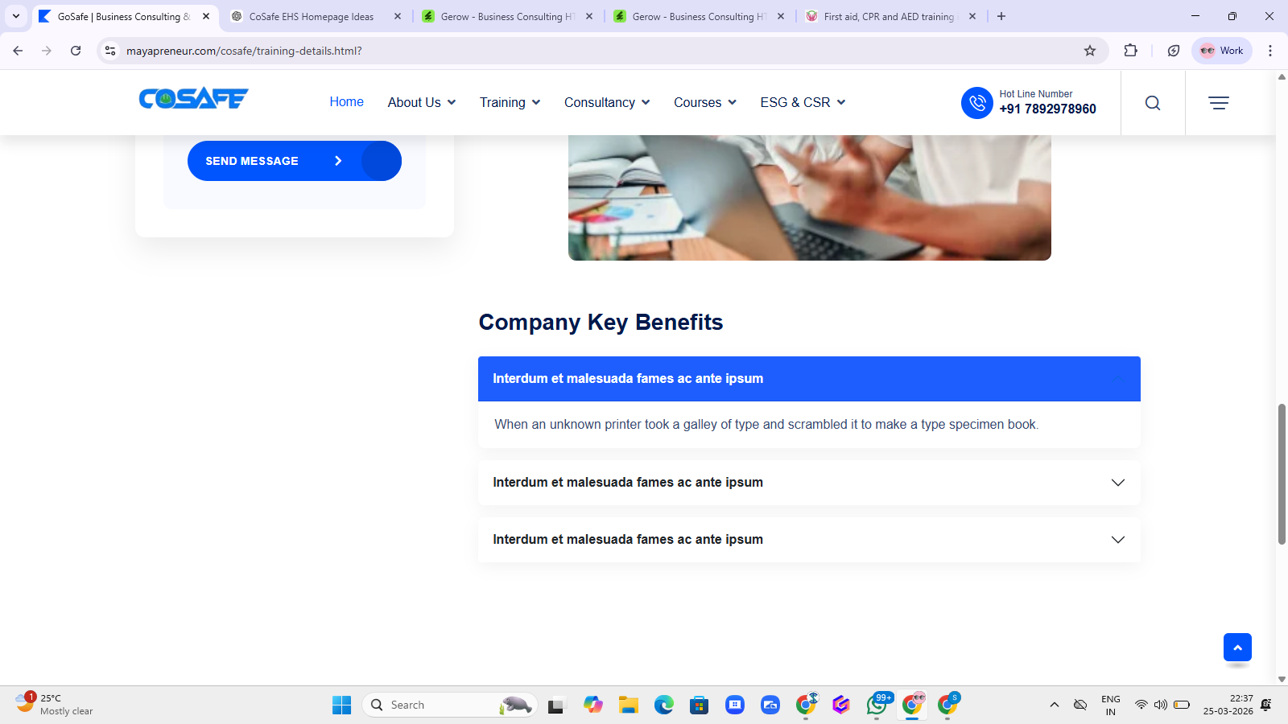 | Below the contact form submission  Put-  Training Gallery- Diverting to Image Gallery under resources  Faq- Put this down to the Training Gallery and diverting to the resources below FAQ page
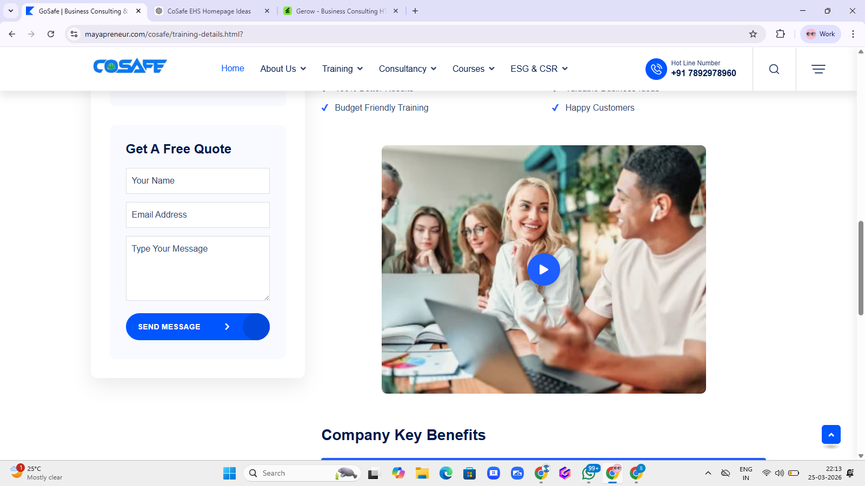 | Remove this video from the page
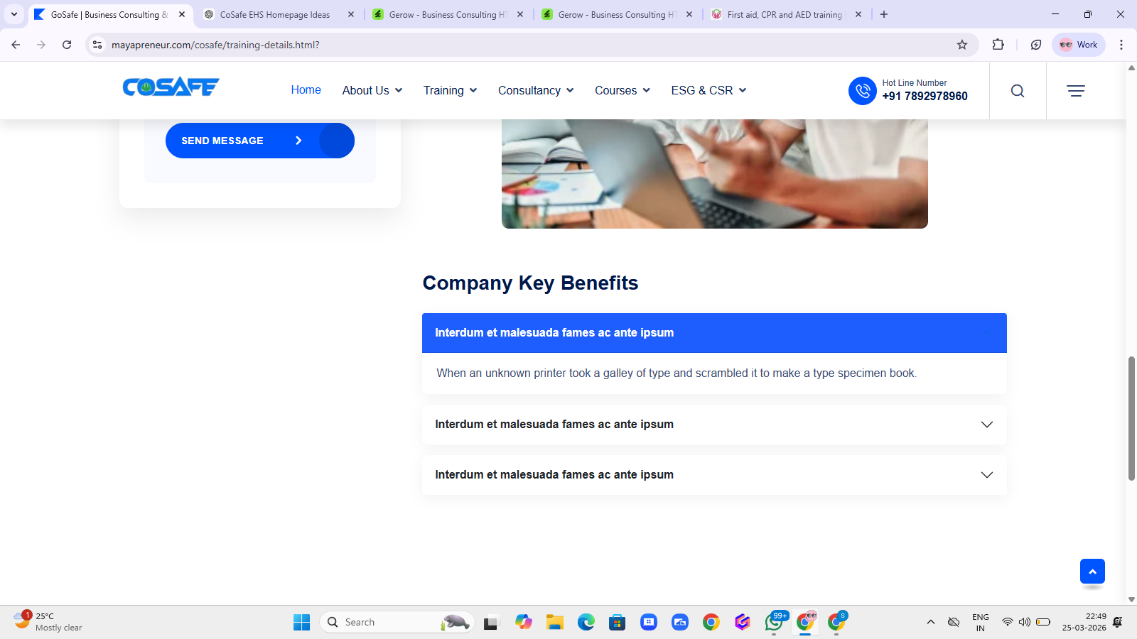 | Remove this faq
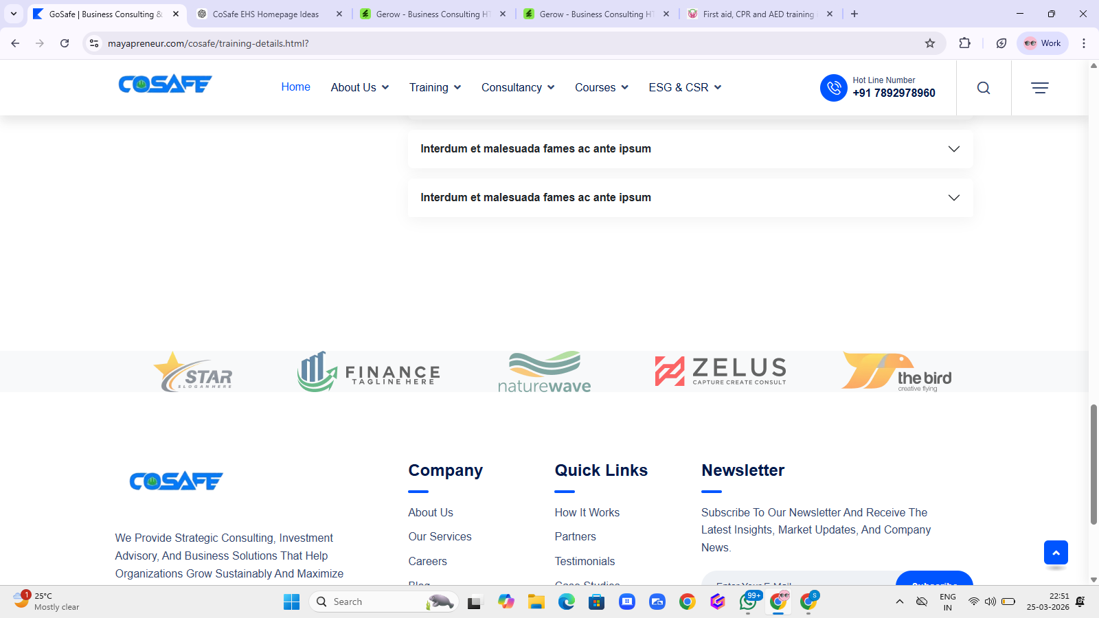 | In Place of logo line, we need to put Final Closing Line as below, this line will be different for the each training page  Be prepared to respond when every second counts — because the right action can save a life.

First Aid Training page Content

✅ 🔹 1. Overview
First Aid Training equips individuals with essential life-saving skills to respond effectively during medical emergencies. The program focuses on practical, real-world applications to ensure participants can act confidently until professional medical help arrives.
With expert guidance and hands-on learning, this training enhances workplace safety, emergency preparedness, and response capability across industries.

✅ 🔹 2. Training Modules

Basic First Aid Fundamentals
- Introduction to First Aid & Responsibilities
- Emergency Response Steps
- First Aid Kit Usage

Life-Saving Techniques
- CPR (Adult, Child, Infant)
- AED Awareness & Usage
- Recovery Position
- Choking Management

Injury Management
- Bleeding Control & Bandaging
- Burns & Scalds Treatment
- Fractures & Sprains
- Wound Care

Medical Emergencies
- Heart Attack & Stroke
- Seizures & Epilepsy
- Asthma & Breathing Issues
- Diabetic Emergencies

Workplace Emergency Scenarios
- Electric Shock
- Poisoning & Chemical Exposure
- Heat Stroke & Dehydration

✅ 🔹 3. Training Methodology
Our training methodology is designed to deliver practical, engaging, and result-oriented learning. We combine theory with real-time application to ensure participants are fully prepared for emergencies.
✔ Interactive instructor-led sessions
✔ Hands-on CPR and first aid practice
✔ Real-time simulation and mock drills
✔ Scenario-based emergency exercises
✔ Expert demonstrations with guidance
✔ Participant practice, assessment & feedback
We focus not just on knowledge, but on building confidence to act during critical situations.

✅ 🔹 4. Program Details

Duration
Half Day (4 Hours) / Full Day (6–8 Hours) – Flexible as per requirement

Certification
Participants will receive a recognized First Aid Training Certificate upon successful completion

Certificate Validity
Valid for 2 Years (Refresher training recommended thereafter)

Training Language
Kannada / Hindi / English / Telugu

Compliance & Legal Relevance
This training supports workplace safety compliance as per:
- Factories Act, 1948 (First Aid Provisions)
- Occupational Safety, Health and Working Conditions Code, 2020
- National Building Code (NBC) – Safety Guidelines

Who Should Attend
✔ Employees & Industrial Workforce
✔ Safety Officers & Supervisors
✔ Corporate Teams & Facility Staff
✔ Students & General Public

Key Outcomes
✔ Improved emergency response capability
✔ Faster and confident decision-making
✔ Reduced severity of injuries
✔ Enhanced workplace safety compliance

